It looks like you have a Bash script that toggles CPU cores based on predicted usage, measures CPU power consumption, and estimates energy consumption. You want to create a report on the prediction and scaling of CPU cores, regression, and energy consumption using the provided format. Here's a breakdown of how you can structure your report:

1. **Introduction:**

The growing need for computers to handle more tasks brings a problem: how do we use our computer's power efficiently without using too much energy? Imagine a scenario where we could make our computers work efficiently while keeping energy usage in check. This report delves into a fresh approach that combines autoregressive prediction and adjusting the number of active CPU cores. Essentially, it explores a smart way to predict and manage computer performance to optimize usage and, at the same time, minimize energy consumption.

1. **Background:**  
    Modern computers have powerful processors designed with multiple cores, allowing them to handle numerous tasks simultaneously. However, effectively managing these resources is crucial. Poor management can lead to excessive energy usage and potential overheating. Conversely, inefficient use of processing power may hinder overall computer performance. Striking a balance between these factors is essential for both energy savings and ensuring optimal computer functionality.

Traditionally, computer systems have used static approaches to CPU management, assigning a fixed number of cores regardless of the actual workload. This rigid allocation often results in inefficiencies, especially during periods of low demand when more cores are active than necessary. This report introduces a dynamic solution, employing a method that adjusts CPU core usage based on predictive modeling. The dynamic CPU management strategy utilizes autoregressive prediction, analyzing past CPU usage patterns to predict future demands. The goal is to allocate resources wisely by activating or deactivating CPU cores in anticipation of changes in workload.

1. **Purpose of the Report:**

The purpose of this report is to delve into the innovative approach outlined in the script, focusing on predicting CPU usage, scaling CPU cores, and estimating energy consumption. Our primary goal is to provide a comprehensive understanding of how these dynamic strategies can optimize computer performance while minimizing energy consumption.

Specifically, we aim to achieve the following objectives:

1. Explore the concept of dynamic CPU management, emphasizing the utilization of autoregressive prediction and core scaling.
2. Assess the effectiveness of autoregressive prediction in anticipating future CPU usage. Analyze how accurate predictions contribute to informed decision-making in resource allocation.
3. Investigate the implications of scaling CPU cores based on predicted CPU usage. Determine how this dynamic adjustment influences overall system efficiency and energy consumption.
4. Delve into the process of estimating energy consumption in relation to CPU usage patterns. Understand the potential energy savings achieved through judicious resource allocation.
5. Emphasize the importance of optimizing CPU performance in the context of increasing computational demands and the need for energy efficiency. Showcase how the outlined strategies contribute to achieving this balance.
6. **Scope and Limitations:**

The scope of our study is to focus on understanding and testing a system that smartly adjusts the number of active CPU cores based on predictions. We'll explore how well it predicts CPU usage, how this affects energy use and computer performance, and where we can use this approach effectively.

It's crucial to recognize that our study leans on simulated data, which may not perfectly replicate real-world scenarios. The actual performance of the code in dynamic conditions might differ. We aim to provide valuable insights, but it's essential to keep in mind that our findings might not apply universally to every computer setup or scenario.

1. **Literature Review**

Summarize relevant literature on CPU usage prediction, autoregression, and energy consumption estimation. Discuss any existing methods, tools, or research in this area.

Efficient management of a computer's CPU has been a focal point in the technology landscape. Let's look at what others have found in this area.

1. **Predicting CPU Usage:** People have tried to figure out how to predict when a computer will need more power. Some studies used fancy math models to guess future CPU use accurately this helps to predict and plan ahead for the computer's workload.
2. **Using Auto-regression for CPUs:** We have uses something called "autoregressive prediction." This idea isn't new; other studies have used it to understand and predict how a computer uses its CPU over time. It's like looking at past behavior to guess what might happen in the future.
3. **Estimating Energy Use:** Understanding how much energy a computer uses is essential. Research has looked into making algorithms that use less energy when the CPU is working hard. Our code is doing something similar – trying to figure out how much energy the computer needs based on how it uses the CPU.
4. **What's Next:** Looking ahead, there's a buzz about using smart technology like artificial intelligence to make computers even better at managing their resources. A recent study introduced a cool idea that combines prediction with learning to make CPU management even smarter.
5. **Methodology:**

#### 3.1 Research Design

Describe the overall design of your study, including the script's purpose, the rationale for using autoregression, and how energy consumption is estimated.

#### 3.2 Data Collection

Explain how CPU usage and power consumption data are collected in your script. Discuss any assumptions made and potential sources of error.

#### 3.3 Data Analysis

Detail the autoregression approach used for predicting CPU usage. Discuss the methodology for toggling CPU cores based on predictions.

1. **Findings:**

#### 4.1 CPU Usage Prediction

Present the results of your autoregression model for predicting CPU usage.

#### 4.2 CPU Core Scaling

Discuss the outcomes of the CPU core scaling process based on predicted CPU usage.

#### 4.3 Energy Consumption Estimation

Report the estimated energy consumption and how it correlates with CPU usage and core scaling.

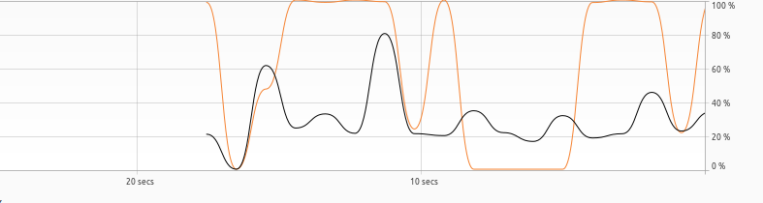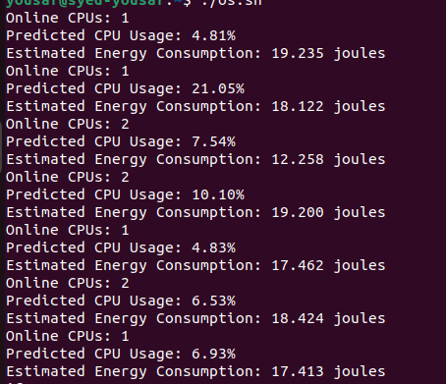

1. **Discussion**

Analyze and interpret your findings. Discuss the implications of CPU core scaling on energy consumption and the effectiveness of the autoregression model.

1. **Conclusions:**

Summarize the key findings of your study and their implications for optimizing CPU performance and energy consumption.